**Chapter 11**

**Determination of the optimal thickness of insulation on a pipe**

Vincenzo Bianco. University of Genoa, DIME-TEC, Division of Therma Energy and Environmental Conditioning, Via All’Opera 15/A, 16145 Genoa, Italy

**11.1 Description of the case**

A new district heating plant fueled with natural gas is under development. The plant is located in the city of Turin (Italy) and its start-up is expected in the beginning of the year 2017.

Its function will be to provide hot water for sanitary and heating purposes to a new district.

To this aim water is supplied to the transportation pipes to a temperature of 90 ̊C. These pipes are exposed to the external environment, manufactured in stainless steel and have a diameter of 30 cm with a thickness of 0,3 cm.

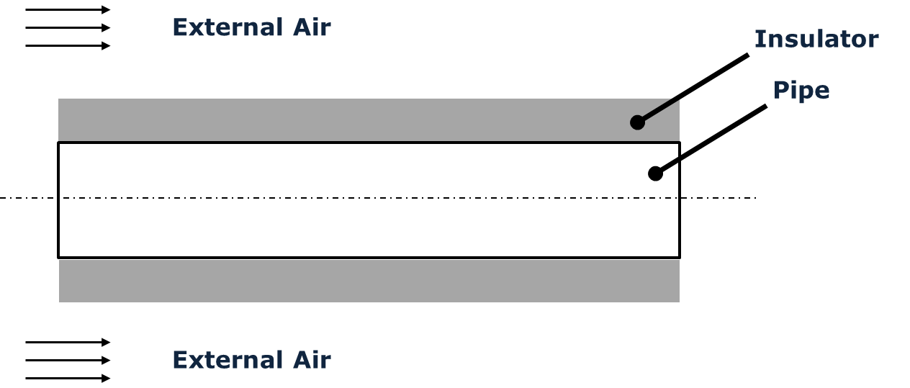

Figure 11.1. Schematic of the reference problem

Approximately, 1 km of these pipes is necessary to reach all the building blocks. The connection among the heating plant and the building blocks is obtained by using ten equal circuits. In order to avoid thermal dispersions and to save fuel, an insulator should be placed on the pipe surface.

Therefore an energy efficiency expert is contacted in order to determine the optimal thickness of the insulator to put on the pipes.

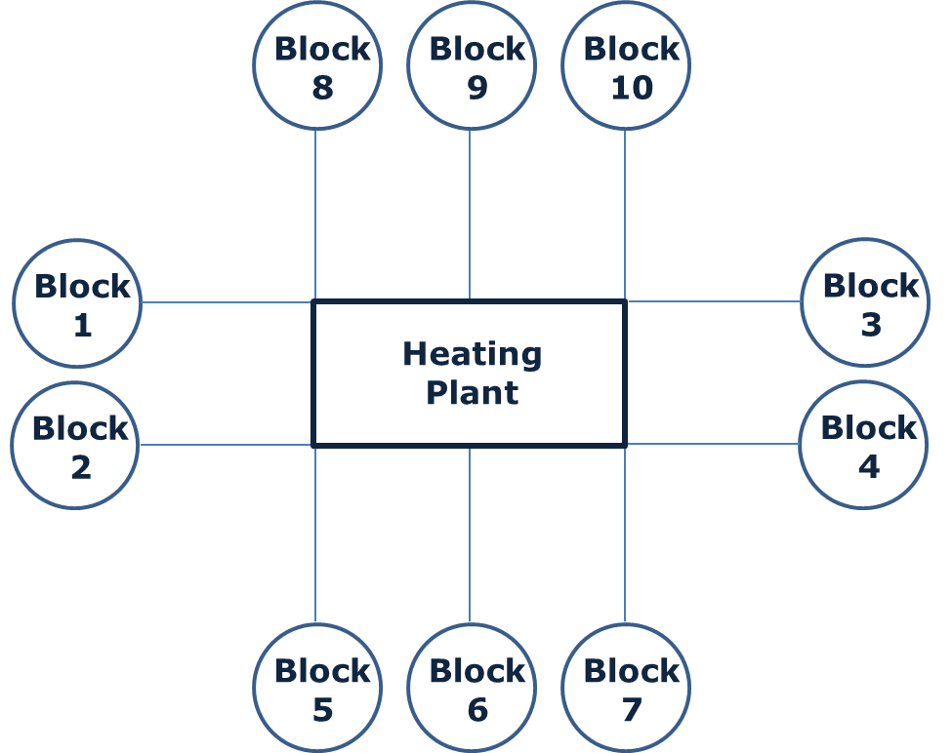

Figure 11.2. Configuration of the distribution system

**11.2 Available data**

Climatic data for the city of Turin are available, in particular average monthly environment temperature and wind velocity (Table 11.1).

Pipes are manufactured in stainless steel, whose thermal conductivity is assumed to be equal to 15 W/(mK). Insulator is assumed to have a duration of 25 years, a thermal conductivity of 0,06 W/(mK) and a cost of 10 €/cm/m2.

Table 11.1 Monthly distribution of average temperature and wind velocity for the city of Turin

|  |  |  |  |  |  |  |  |  |  |  |  |  |
| --- | --- | --- | --- | --- | --- | --- | --- | --- | --- | --- | --- | --- |
| **Month** | **1** | **2** | **3** | **4** | **5** | **6** | **7** | **8** | **9** | **10** | **11** | **12** |
| Temp. (̊C) | 1,7 | 3,5 | 8,4 | 11,6 | 16,3 | 20,3 | 22,8 | 22,2 | 18,1 | 12,7 | 6,6 | 2,4 |
| Wind (m/s) | 30,0 | 30,0 | 20,0 | 15,0 | 10,0 | 5,0 | 5,0 | 5,0 | 10,0 | 15,0 | 20,0 | 30,0 |

Finally, the evolution of the heat supply is provided from a third party study and it is reported in terms of year over year evolution with respect to the value of the year 2016 which is equal to 0.130 €/kWht.

Table 11.2 Year over year evolution of the heat cost

|  |  |
| --- | --- |
| **Year** | **Evolution Coefficient** |
| 2017 | 2,93% |
| 2018 | 3,01% |
| 2019 | 2,92% |
| 2020 | 3,00% |
| 2021 | 2,99% |
| 2022 | 2,99% |
| 2023 | 3,06% |
| 2024 | 2,97% |
| 2025 | 3,04% |
| 2026 | 3,04% |
| 2027 | 3,03% |
| 2028 | 3,02% |
| 2029 | 3,01% |
| 2030 | 3,08% |
| 2031 | 3,07% |
| 2032 | 3,06% |
| 2033 | 3,05% |
| 2034 | 3,05% |
| 2035 | 3,05% |
| 2036 | 3,05% |
| 2037 | 3,05% |
| 2038 | 3,05% |
| 2039 | 3,05% |
| 2040 | 3,05% |

**11.3 Discussion**

This case study consists in finding the optimal diameter of insulation to install on the transportation pipes of a district heating plant. The problem can be analyzed from a thermal and economic perspectives. From the thermal perspective, an insulator as thick as possible is the best solution, because it allows to minimize thermal loss. On the other hand, the insulation has a cost and this poses a limit to its utilization, therefore both the issues must be considered at the same time.

In particular, the main parameters to consider are the heat losses from the tube (which are function of the insulation thickness), the investment cost (cost of insulation) and the amount and value (financial value) of energy saved by insulating the pipes. It must be noticed that the value of energy saved varies within the time, because heat cost evolves in the time.

**11.4** **Thermal analysis**

As reported in Fig. 11.1, the problem consists in the determination of the heat transfer rate from a pipe of circular section, subjected to heat conduction and convection.

Heat transfer is due to conduction through the pipe walls and insulator thickness, whereas convection on the internal side of the pipe because of the water flow and on the external side convection is due to the air flow (wind blows).

External conditions to perform thermal calculations are reported in Table 11.1.

If the total length of the tubes (L) is 1 km and the number of distribution circuits (n) is equal to 10, the length of each distribution line (l) can be calculated as follows:

 (Eq. 11.1)

Air properties are taken at 300 K and reported in the Table 11.3.

By using the air properties at 300 K and wind velocity (w), Reynolds number (Re) is calculated in the following way:

Table 11.3. Air properties at 300K

|  |  |  |  |  |  |
| --- | --- | --- | --- | --- | --- |
| Property | Units of Measure | Value | Property | Units of Measure | Value |
| Thermal Conductivity (k) | W/(mK) | 0.0263 | Prandtl Number (Pr) | n.a. | 0.707 |
| Specific Heat (Cp) | J/(kgK) | 1007 | Kinematic viscosity (υ) | m2/s | 0,00001589 |

 Eq. (11.2)

Where Lc is a characteristic length which depends on the cases taken into account. In the present problems two characteristic lengths, namely the diameter and the length of the pipe, are taken into account, in order to determine the convection coefficients for the cases of cross flow and parallel flow.

The correlation of Nusselt number considered for cross flow is the following (Cengel and Ghajar, 2015):

 Eq. (11.3)

Correlation (11.3) is valid for gas and liquids and for Re between 40.000 and 400.000.

As for the parallel flow, the correlation of Nu for a flat plate (Cengel and Ghajar, 2015) is taken into account by assuming that the radius of curvature of the pipe is not too large, therefore the considered equation is:

 Eq. (11.4)

Which is valid for Pr between 0,6 and 60 and Re between 5·105 and 107.

Once that Nu number is determined, it is possible to calculate the average convection heat transfer. Nu number can be written as:

 Eq. (11.5)



Figure 11.3

Therefore, from Eq. (11.5), the average heat transfer coefficient can be determined:

 Eq. (11.6)

Where k is the thermal conductivity of air, reported in Table 11.3 and Lc is a characteristic length (external diameter of the pipe in case of cross flow and length of the pipe in case of parallel flow).

On the basis of the above mentioned equations implemented in a spreadsheet, monthly data (wind velocity varies month by month) for the heat transfer coefficient are calculated for the cases of cross flow and parallel flow.

Then, in order to consider these effect in a “rough” and simple way, the average between the two coefficients is considered. The results of the calculations are shown in Fig. 11.3.

……………………………………………………………………………………………………………………………………………………………………………………………………………………

…………………………………………………………………………………………………………

…………………………………………………………………………………………………………

**References**

Cengel Y, Ghajar AJ. Heat and Mass Transfer. McGraw-Hill, 2015.